Ex. No:1 Roll No: 230701391

Date:31/07/2024 Name: Musa Haji

CREATION OF DATABASE AND DML OPERATIONS

1. Create MY_EMPLOYEE table with the following structure

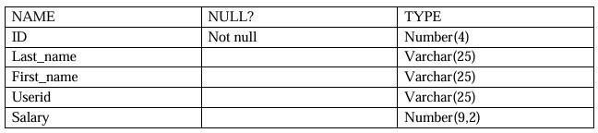

create table MY_EMPLOYEE(ID NUMBER(4) NOT NULL, LAST_NAME VARCHAR(25), FIRST_NAME VARCHAR(25), SALARY NUMBER(9,2));

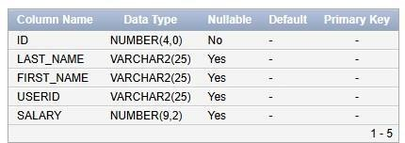

1. 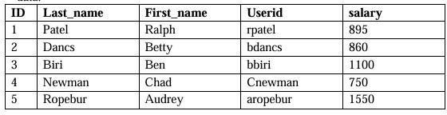Add the first and second rows data to MY_EMPLOYEE table from the following sample data.

insert into MY_EMPLOYEE(ID,LAST_NAME,FIRST_NAME,USERID,SALARY)

values (1,'Patel','Ralph','rpatel',895)

into MY_EMPLOYEE(ID,LAST_NAME,FIRST_NAME,USERID,SALARY) values

(2,'Dancs','Betty','bdancs',860)

into MY_EMPLOYEE(ID,LAST_NAME,FIRST_NAME,USERID,SALARY) values

(3,'Biri','Ben','bbiri',1100)

into MY_EMPLOYEE(ID,LAST_NAME,FIRST_NAME,USERID,SALARY) values

(4,'Newman','Chad','Cnewman',750)

into MY_EMPLOYEE(ID,LAST_NAME,FIRST_NAME,USERID,SALARY)

values (1,'Ropebur','Audrey','aropebur',1550);

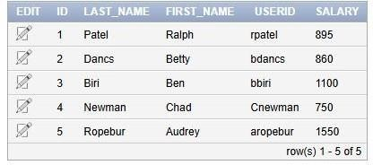

1. Display the table with values:

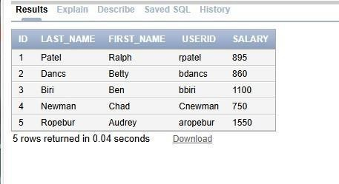SELECT * from MY_EMPLOYEE;

1. Populate the next two rows of data from the sample data. Concatenate the first letter of the first_name with the first seven characters of the last_name to produce Userid.

insert into MY_EMPLOYEE(ID,LAST_NAME,FIRST_NAME,USERID,SALARY)

values (6,'Priyanga','Mohan','pmohan',7897)

into MY_EMPLOYEE(ID,LAST_NAME,FIRST_NAME,USERID,SALARY) values

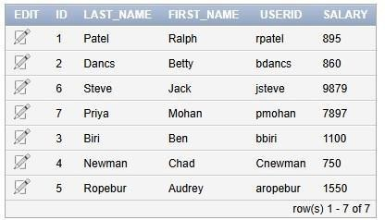(7,'Steve','Jack','jsteve',9879);

1. Delete Betty dancs from MY _EMPLOYEE table.

delete from MY_EMPLOYEE where LAST_NAME='Dancs';

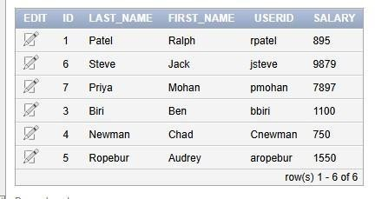

1. Empty the fourth row of the emp table.

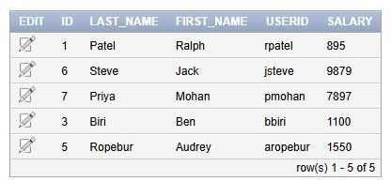delete from MY_EMPLOYEE where ID=4;

1. Make the data additions permanent.

commit;

1. Change the last name of employee 3 to Drexler.

update MY_EMPLOYEE set LAST_NAME='Dexler' where ID=3;

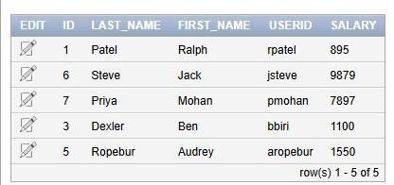

1. Change the salary to 1000 for all the employees with a salary less than 900.

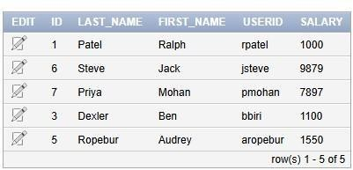update MY_EMPLOYEE set SALARY=1000 where SALARY<900;